Role Title: | Multi-Skilled Engineer
Location: | Supply Chain Centres
Reports to Role: | Site Engineering Manager
Direct Reports: | None
Grade: | 3
Notice Period: | 4 weeks
Version Number and date: | May 2019

ROLE PURPOSE
Ensure that the engineering department functions as a key service provider to the Supply Chain, through timely breakdown response, planned maintenance and project work. Focusing on continuous improvement whilst ensuring that departmental goals and targets are achieved to support the long-term engineering strategy.

MAIN AREAS OF RESPONSIBILITY
- Responsible for planned preventative maintenance of production plant, automated ASRS and associated services within the Domino’s Group during your shift.
- Provide onsite engineering work, breakdown response and corrective actions to enable the maximisation of production efficiency and productivity.
- Perform projects and installations as and when required
- Support the Engineering Manager to all aspects of continuous improvement within the production area.
- Provide training and development to apprentices ensuring the transfer of knowledge to enable safe and practical skills to be attained in the Engineering field.
- Work with designated quality management systems as required.
- Comply with all legal and Company policies and procedures regarding health and safety to ensure you work in a manner that keeps you and your colleagues safe.
- Proactively seek methods of continuous improvements within the department and propose these to relevant managers.
- Comply with all applicable UK and Ireland Data Protection and ePrivacy legislation and report non-compliances where identified to the Data Protection team
- Responsible for actively participating in Domino’s performance development process to ensure knowledge and skills remain current and relevant for role.
The main areas of responsibility are not intended to be exhaustive but gives a general indication of the role. It is the nature of the Company that tasks and responsibilities are in many circumstances, unpredictable and varied. All colleagues are therefore, expected to work in a flexible way when the occasion arises and acknowledge that tasks not specifically covered in their role profile are not excluded.

ACCOUNTABILITY
- Ensure legal compliance and co-operate with Company policy and procedure relating to ISO Standards and Food Hygiene Standards whilst in performance of duties and on Company premises.
- To maintain an up to date knowledge of all regulations related to their responsibilities.
- Continue to develop own talents and strengths and address any areas of self-development

KNOWLEDGE, SKILLS, ABILITY & EXPERIENCE
- Mechanical or electrical skills either through apprentice training plus relevant experience; or degree in Mechanical or Production Engineering plus relevant experience.
- Previous similar experience, ideally gained within a Food Production environment
- A understanding of Health and Safety Legislation and Food Safety Standards

COMPETENCIES
At Domino’s we recruit, develop and retain the best talent, we work hard and have fun along the way, and our colleagues are;
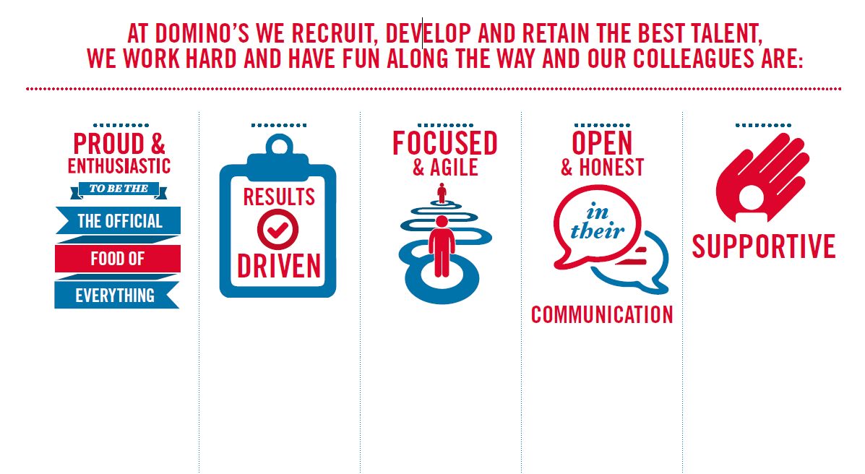
Proud & Enthusiastic: A positive advocate of their brand energises others through their passion.

Results Driven: Exceeds goals, pushes themselves to deliver, gets the job done at pace.

Focused & Agile: Works towards business goals, flexible to adapt and innovate as needed.

Open & Honest: Has sincere and two-way conversations, listens to and respects the views of others.

Supportive: Encourages and helps others, builds relationships, contributes to a positive environment

