Role Title: | Class 1 Driver
Location: | Supply Chain - Avonmouth
Reports to Role: | Despatch Manager
Direct Reports: | N/A
Grade: | 6
Notice Period: | 1 Week?
Version Number and date: | Version 1: January 2020

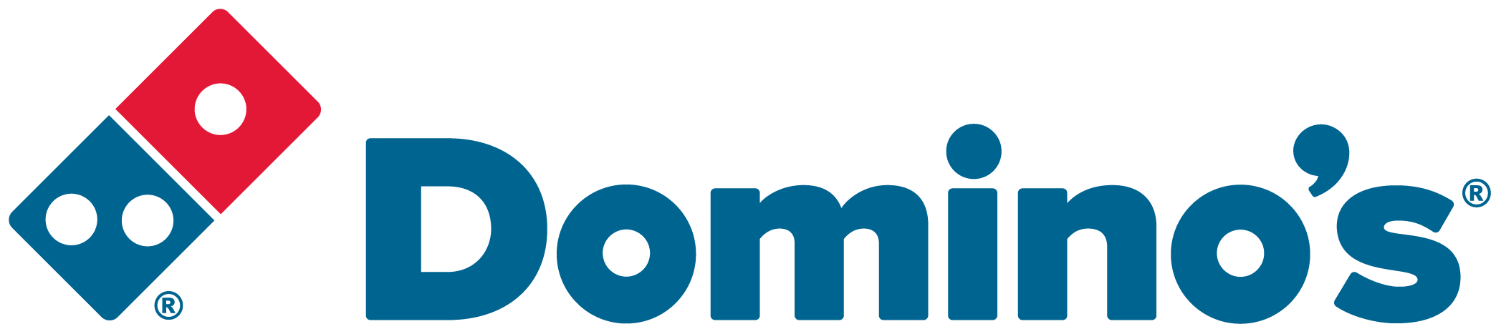ROLE PURPOSE
Ensure the accurate, safe and timely delivery of goods to Domino’s Pizza Stores throughout the UK and Ireland in line with Domino’ Pizza policies and standard operating procedures.

MAIN AREAS OF RESPONSIBILITY
- Make Health & Safety a priority by complying with all legal and Company policies and procedures to ensure you work in a manner that keeps you and your colleagues safe.
- Delivery of goods into Domino’s Pizza Stores by handballing products; placing goods in the designated areas whilst ensuring accuracy and checking the goods delivery against the delivery paperwork.
- Ensure high customer service standards are maintained at all times.
- Ensure you present yourself to work in the correct uniform and standards of personal presentation are maintained.
- Comply with all Transport legislation including Working Time Directive, EU Driver’s Hours and Tachograph Laws.
- To comply with all Company procedures ensuring that all paperwork associated with the role is completed accurately and returned to the Central Office in a timely manner.
- Notify the Central Office at the earliest opportunity of any delays to your deliveries, if you are unable to make a delivery or if you are likely to run out of driving hours prior to completing all your deliveries.
- Collection of empty dough trays, cages and dollies from Domino’s Pizza Stores for return to the Supply Chain Centre.
- Report any vehicle defects to the Central Office immediately for the appropriate action to be taken.
- On occasion be expected to work as a lone worker and carry out all appropriate duties.
- Comply with all applicable UK and Ireland Data Protection and e-Privacy legislation and report non-compliances where identified to the Data Protection team.
- Responsible for actively participating in Domino’s performance development process to ensure knowledge and skills remain current and relevant for role.

The main areas of responsibility are not intended to be exhaustive but gives a general indication of the role. It is the nature of the Company that tasks and responsibilities are in many circumstances, unpredictable and varied. All colleagues are therefore, expected to work in a flexible way when the occasion arises and acknowledge that tasks not specifically covered in their role profile are not excluded.

ACCOUNTABILITY
- Maintain a working knowledge of all the businesses within the Domino’s Group
- Participate in maintaining and developing the strong working relationship between Domino’s Pizza Group and it’s Franchisee’s.
- Ensure an impressive service delivery to our Franchisee’s

KNOWLEDGE, SKILLS, ABILITY & EXPERIENCE
- You must possess a full license relevant to the role, e.g. LGV C1, C, C+E license and ideally with no penalty points
- Current Driver CPC holder
- Holder of a valid Tachograph card
- Manual Handling training certificate
- Basic Food Hygiene Certificate
- A minimum of 6 months and ideally at least 1 years current driving experience with HGVs
- Multi-drop delivery experience
- Experience of hygiene procedures, standards and equipment in the chilled food industry
- Working knowledge of Transport Legislation, Working Time Directive, EU Drivers’ Hours and Tachograph Law

COMPETENCIES
At Domino’s we recruit, develop and retain the best talent, we work hard and have fun along the way, and our colleagues are;
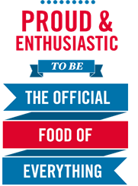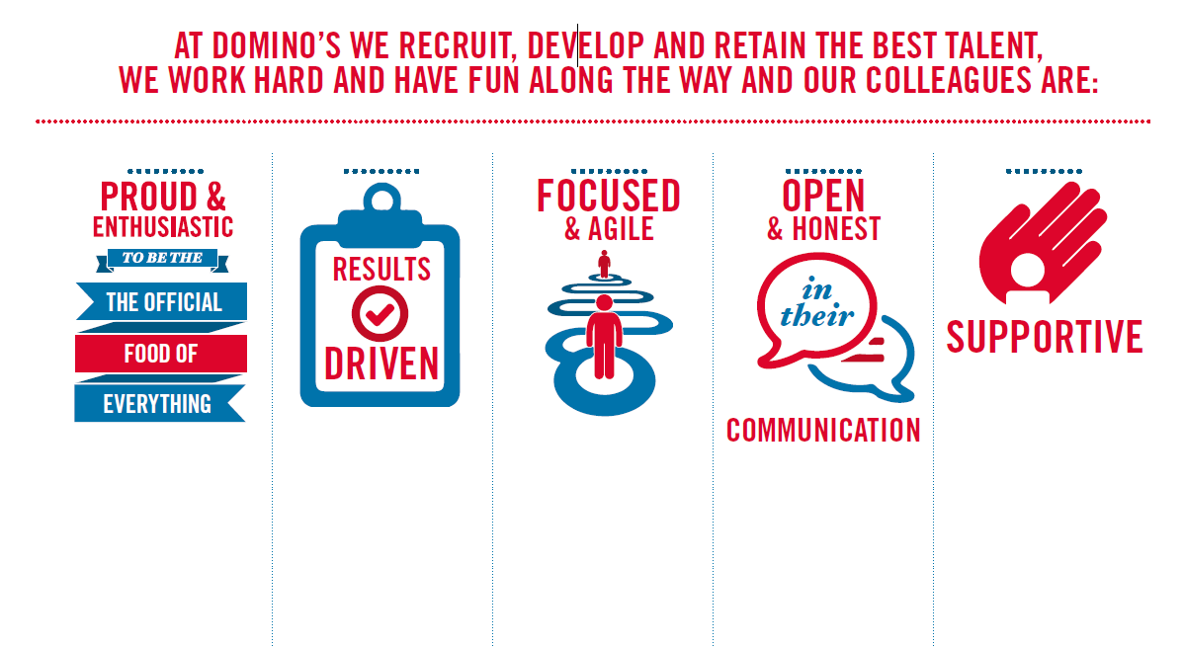
Proud & Enthusiastic: A positive advocate of their brand energises others through their passion.

Results Driven: Exceeds goals, pushes themselves to deliver, gets the job done at pace.

Focused & Agile: Works towards business goals, flexible to adapt and innovate as needed.

Open & Honest: Has sincere and two-way conversations, listens to and respects the views of others.

Supportive: Encourages and helps others, builds relationships, contributes to a positive environment

