Role Title: | Platform Support Engineer
Location: | Milton Keynes
Reports to Role: | Platform Support Team Leader
Direct Reports: | None
Grade: | TBC
Notice Period: | 4 weeks
Version Number and date: | 1.0: 19/03/2024

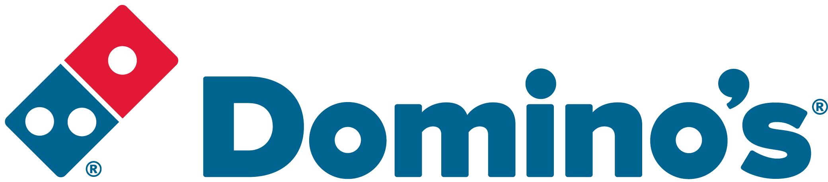ROLE PURPOSE
This role is part of the DPG IT Platform Engineering and Architecture Team, and you will play a crucial role in ensuring the smooth operation of our internal IT systems. You’ll be responsible for diagnosing and resolving technical issues, providing excellent customer service, and maintaining a high level of client satisfaction.

We’re looking for someone who is passionate about technology and able to drive the team to deliver a first-class user experience.

MAIN AREAS OF RESPONSIBILITY
- Build a first-class environment to provide a first class user experience
- Play an active role in transforming and supporting the IT platforms.
- Troubleshoot hardware and software issues, including desktops, laptops, printers, and peripherals.
- Install, configure, and maintain operating systems and software applications.
- Set up and manage user accounts, permissions, and security settings.
- Collaborate with other IT team members to resolve complex technical problems.
- Document support activities and maintain accurate records.
- Provide training and guidance to end-users on IT-related topics.
- Responsible for the build, configuration and lifecycle management of all end user assets
- Ensure our On-premise and Azure Active Directory are kept up to date and maintained
- Administration of Office 365, including user management and licensing
- Managed our printer estate using Secure Print Management
- Responsible for the management of the on-premise and exchange online email platforms
- Monitor, support and maintain the infrastructure in accordance with the Incident, Major Incident and Problem Management processes with a focus on driving down repeat tickets.
- Comply with all legal and Company policies and procedures regarding health and safety to ensure you work in a manner that keeps you and your colleagues safe.
- Comply with all applicable UK and Ireland Data Protection and ePrivacy legislation and report non-compliances where identified to the Data Protection team
- Responsible for actively participating in Domino’s performance development process to ensure knowledge and skills remain current and relevant for role.

The main areas of responsibility are not intended to be exhaustive but gives a general indication of the role. It is the nature of the Company that tasks and responsibilities are in many circumstances, unpredictable and varied. All colleagues are therefore, expected to work in a flexible way when the occasion arises and acknowledge that tasks not specifically covered in their role profile are not excluded.

ACCOUNTABILITY
- Be the face of the Platform Support team on site, providing a friendly, relaxed but professional colleague experience
- Working with other members of the Platform Engineering and Architecture Team, ensure that all Incidents and Service Request are dealt with in accordance with the team SLA’s.
- Champion and drive digital transformation
- Administration of Authentication systems - VPN, Active Directory (on-premise and Azure) and Office 365
- Support Digital Workplace solutions (Video Conferencing, Wi-Fi, Printing etc.)
- Manage the lifecycle of DPG Assets (Laptop’s, Phones etc.)

KNOWLEDGE, SKILLS, ABILITY & EXPERIENCE
- Be at ease with the Domino’s culture that is informal, friendly, open and passionate.
- Be an innovative and positive team player who is prepared to challenge the status quo. Having a ‘Can do’ attitude.
- The ability to form strong, mutual and professional business relationships with internal colleagues
- Experience of managing and prioritizing own workload
- High Integrity – can and does deliver what they say they will.
- Strong knowledge with at least 4 of the following technologies;
  - Microsoft Windows client and server operating systems as well as macOS, iOS and Android
  - Microsoft Office 365
  - Cisco Networking Technologies
  - Palo Alto Firewalling
  - Group Policy / Active Directory
  - General LAN and WAN networking concepts including switches and firewalls
  - Active Directory (Azure and on-premise) / Exchange Online
- Relevant Industry recognised certification or demonstrable industry experience

COMPETENCIES
At Domino’s we recruit, develop and retain the best talent, we work hard and have fun along the way, and our colleagues are;
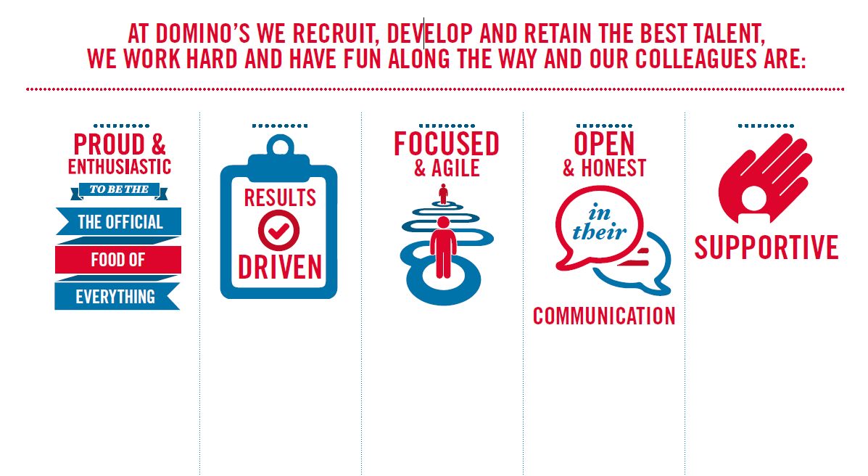
Proud & Enthusiastic: A positive advocate of their brand energises others through their passion.

Results Driven: Exceeds goals, pushes themselves to deliver, gets the job done at pace.

Focused & Agile: Works towards business goals, flexible to adapt and innovate as needed.

Open & Honest: Has sincere and two-way conversations, listens to and respects the views of others.

Supportive: Encourages and helps others, builds relationships, contributes to a positive environment

