Role Title: | Supplier Assurance Manager
Location: | Multisite Mainly MK
Reports to Role: | Director of Food Safety and Quality Assurance
Direct Reports: | Up to 1
Grade: | 2
Notice Period: | 3 months
Version Number and date: | V2 5.7.2023

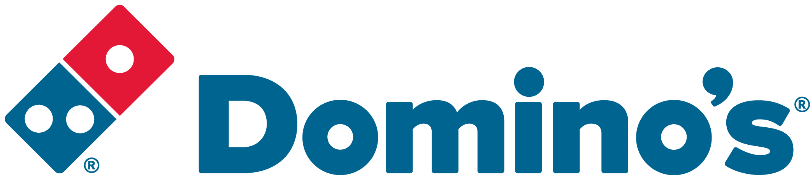ROLE PURPOSE
Lead engagement with own portfolio of suppliers managing supplier quality, service, cost and risk within the supply chain. Communicate the Domino’s supplier requirements to the supply base to drive continuous improvement through regular review and quality improvement plans. Recognised as subject matter experts.

MAIN AREAS OF RESPONSIBILITY
- Accountable for own portfolio of food, packaging / food contact equipment ensuring brand integrity at all times working with Director of food safety and technical to improve technical policies and supplier compliance audit standard
- Via risk assessed supplier auditing determine if supplier’s quality systems, technical competence and product meet expectations and standards – use risk-based approach to determine relevant level of quality assurance
- Managing the supplier performance through score cards & KPIS ensuring that due diligence requirements are met to drive continuous improvements.
- Ensure full supplier adherence to Dominos policy and commitments as laid out in the Supplier Manual and manage compliance to product specifications and QAS.
- Supplier training and engagement to improve policy understanding and compliance
- Engage with suppliers on technical and operational matters to assess the quality of ingredient brought using a Quality Control program to measure microbiological and quality criteria.
- Conduct announced and unannounced supplier visits to actively drive standards and ensure crisis management and traceability is in place and challenge tested.
- Maintain active and accurate product specifications for product area and carry out regular reviews on these with the supply base
- Co-ordinate and manage incidents related to food safety, legality and quality including decision making, investigation and follow up of actions
- Analyse and investigate store complaints and issues to identify the cause and solution
- Accountability for the supply chain sustainability agenda including decarbonisation (lined to suppliers), food waste, SASB targets, Net Zero, Animal welfare and modern slavery within your accountable area.

The main areas of responsibility are not intended to be exhaustive but gives a general indication of the role. It is the nature of the Company that tasks and responsibilities are in many circumstances, unpredictable and varied. All colleagues are therefore, expected to work in a flexible way when the occasion arises and acknowledge that tasks not specifically covered in their role profile are not excluded.

ACCOUNTABILITY
- Drive the quality agenda across the supply base and product portfolio.
- Ensuring suppliers and products meet the legal expectations on Food Safety & Sustainability.
- Guardian of the brand integrity and ensure the customers’ expectations and needs are upheld.

KNOWLEDGE, SKILLS, ABILITY & EXPERIENCE
- Food Science Degree, Microbiology Degree or equivalent experience demonstrating strong knowledge and experience of food science and regulatory understanding.
- Broad product category experience including high risk products
- Consultative approach to auditing and ability to work with suppliers to achieve required standards
- Technical Management experience in a technical role in Retail/Foodservice or Manufacturing
- High level of technical aptitude
- Highly self-motivated, and capable of working with minimal direction
- Excellent communication and presentation skills with the ability to articulate complex issues in a simple manner to ensure clearly communication channels whilst working with cross functional teams.
- Strong interpersonal skills with the ability to interact with and influence key stakeholders at all levels
- Proficient with web-based specification and supplier management database systems
- UK driving licence, flexible and willingness to travel for the role

OUR VALUES


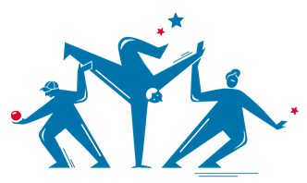
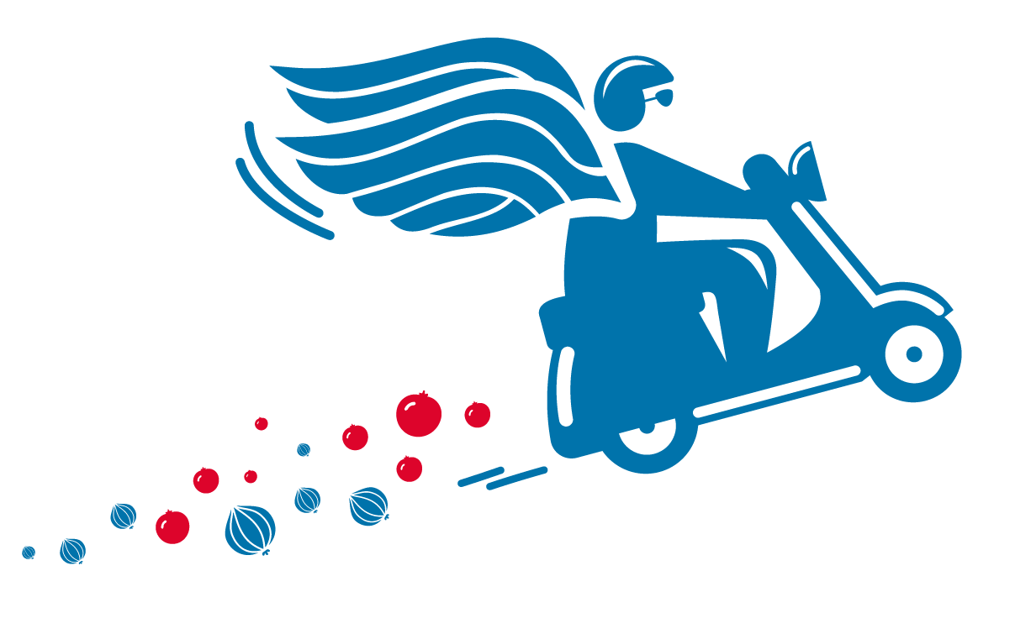

We grow and
win Together
We do the
right thing
We are
one team
We are
bold
We love customers

