Role Title: | Depot Shift Manager
Location: | Cambuslang
Reports to Role: | Site GM
Direct Reports: | Drivers, Driver support & Team Leaders
Grade: | E
Notice Period: | 12 weeks
Version Number and date: | June 2025

ROLE PURPOSE
To oversee, support and direct all colleagues and areas of the SCC whilst on duty, whilst delivering consistent performance and overseeing the day to day running of the operation to ensure that all daily targets are met in the most cost effective, efficient and safe manner.

MAIN AREAS OF RESPONSIBILITY
- Manage the Production operation to ensure the efficient running of all automated machinery within the production department ensuring quality parameters, OEE and Yields are achieved in line with the demand of the Cambuslang depot.
- Manage the Transport operation to ensure the successful delivery of products to Domino’s stores by ensuring efficient use of the driver Rota, whilst providing cover for all delivery routes. Ensure that Paragon, Flexipod and Trutac systems are being utilized correctly by both administration and driver colleagues.
- Manage the Warehouse operation by ensuring sufficient cover for all operational days, Goods In colleagues correctly using the ERP system for supplier deliveries, overseeing the picking and loading teams and ensuring the Scan & Dispatch system is used to its full potential and actively working to reduce daily and weekly mispicks.
- To lead, motivate, manage and develop Team Leaders & colleagues to enable the performance of their responsibilities, providing hands on support to enable their effective performance against KPIs.
- Effectively managing vehicle and driver legal requirements ensuring compliance can be demonstrated to internal and external auditors. Set-up or use existing processes to ensure correct management of the service and maintenance schedules for the fleet.
- Manage the daily ERP operations ensuring all processes are correctly and accurately followed.
- Ensure colleague development, identify areas for improvement and conduct any necessary training to ensure colleagues are competent within their role to drive continuous improvement and improve service and quality.
- Comply with all legal and Company policies and procedures regarding health and safety to ensure you work in a manner that keeps you and your colleagues safe.
- Comply with all applicable UK and Ireland Data Protection and ePrivacy legislation and report non-compliances where identified to the Data Protection team
- Responsible for actively participating in Domino’s performance development process to ensure knowledge and skills remain current and relevant for role.

The main areas of responsibility are not intended to be exhaustive, but gives a general indication of the role. It is the nature of the Company that tasks and responsibilities are in many circumstances, unpredictable and varied. All colleagues are therefore, expected to work in a flexible way when the occasion arises and acknowledge that tasks not specifically covered in their role profile are not excluded.
ACCOUNTABILITY
- Be a reliable and approachable point of contact for direct reports
- Whilst there are policies and procedures in place, the role holder will be required to display a significant level of judgement and autonomy in resolving daily issues in a timely manner.
- Manage the Transport, Warehouse and Production Operation and Colleagues throughout your shift to ensure a safe and effective service delivery to stores.
- To manage the operation on a daily basis, making decisions and understanding the impact these may cause with minimal guidance.

KNOWLEDGE, SKILLS, ABILITY & EXPERIENCE
- Having experience of at least 2 points from the immediate below list would be advantageous:
  - Previous experience of ensuring the correct use of an ERP system such as AX or D365
  - Understanding Transport legislation, working time directive and Tachograph law.
  - Overseeing a production facility and ensuring Food Safety requirements are maintained
  - Previous management experience within a multi-temperature environment.
- Able to demonstrate clear ability to direct and develop teams/individuals to reach tight deadlines and KPIs.
- Ability to problem solve using initiative with a strategic and pragmatic approach.
- Excellent communication skills, at all levels.

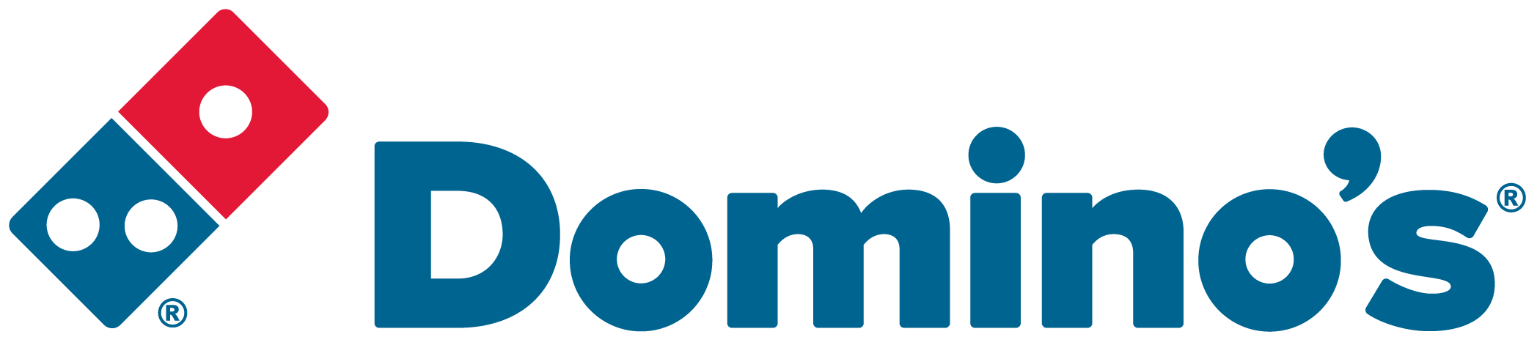 OUR VALUES





We grow and
win Together
We do the
right thing
We are
one team
We are
bold
We love customers

