Role Title: | Driver Trainer
Location: | Cambuslang & Supporting NAS Ireland
Reports to Role: | Depot Shift manager
Direct Reports: | None
Band: | F
Notice Period: | 12 Weeks
Version Number and date: | July 2026

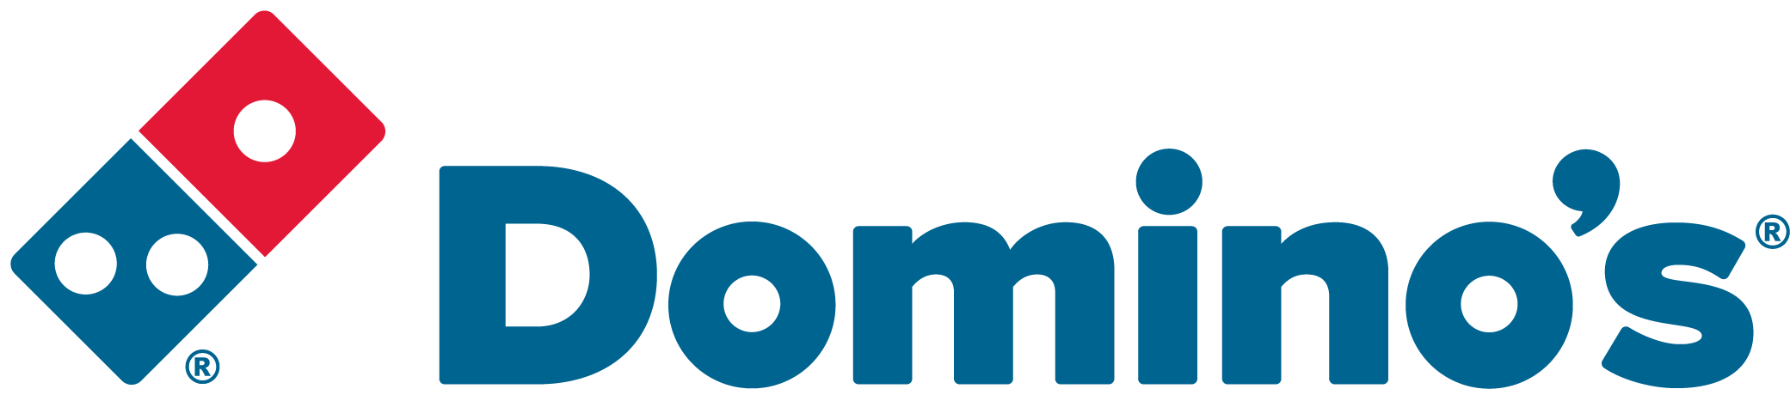ROLE PURPOSE
Assess the driving abilities of all HGV drivers and ensure that all of the drivers receive sufficient and appropriate training and guidance to do their job in a safe, compliant and efficient manner.

MAIN AREAS OF RESPONSIBILITY
- Responsible for carrying out driver assessments in line with the annual plan; assessing driving standards, improving safety, fuel efficiency, reducing accident frequency and to improve overall standards.
- Assess any potential new starters (including temporary workers) and any drivers that have experienced a blameworthy accident.
- Provide sound and accurate advice to drivers and other team members on compliance issues and transport legislation.
- Proactively seek methods of continuous improvements within the department and propose these to managers.
- Ensure that tachograph records for all drivers are monitored and the appropriate reports are compiled and communicated at the desired frequency.
- Monitor full compliance for the drivers by managing adherence to the relevant legislation, to include licence checks, agency worker declarations and other associated tasks, and report
- Conduct other training such as WTD & EU Driver’s Hours training, tachograph training, manual handling training, tail-lift training, LWD training, post accident investigation related training, new equipment training etc.
- Provide KPI information and timely reports to the management team as requested.
- Comply with all legal and Company policies and procedures regarding health and safety to ensure you work in a manner that keeps you and your colleagues safe.
- Comply with all applicable UK and Ireland Data Protection and ePrivacy legislation and report non-compliances where identified to the Data Protection team
- Responsible for actively participating in Domino’s performance development process to ensure knowledge and skills remain current and relevant for role.
- The main areas of responsibility are not intended to be exhaustive, but gives a general indication of the role. It is the nature of the Company that tasks and responsibilities are in many circumstances, unpredictable and varied. All colleagues are therefore, expected to work in a flexible way when the occasion arises and acknowledge that tasks not specifically covered in their role profile are not excluded.
- Conducting on site gate checks.

ACCOUNTABILITY
- Responsible for ensuring high quality delivery standards through promoting adherence to the Standard Operating Procedures to ensure accuracy, efficiency and adherence with Transport legislation and Company policy and procedure.
- Maintain up to date knowledge of legislation changes
- Maintain a working knowledge of all of the businesses within the Domino’s Group
- Support in ensuring an impressive service delivery to our Franchisee’s

KNOWLEDGE, SKILLS, ABILITY & EXPERIENCE
- Previous experience of creating and delivering classroom based training in a Transport function.
- Proven track record in training and assessing with an ability to instruct in a professional manner
- Driver Assessor Qualification
- Driver CPC National
- HGV C1, C+E License
- Safe & Fuel Efficient driving techniques trainer (SAFED)
- An understanding of Health and Safety and Food Safety legislation
- Previous experience with telematic systems
- Good knowledge of tachograph systems

COMPETENCIES
At Domino’s we recruit, develop and retain the best talent, we work hard and have fun along the way, and our colleagues are;
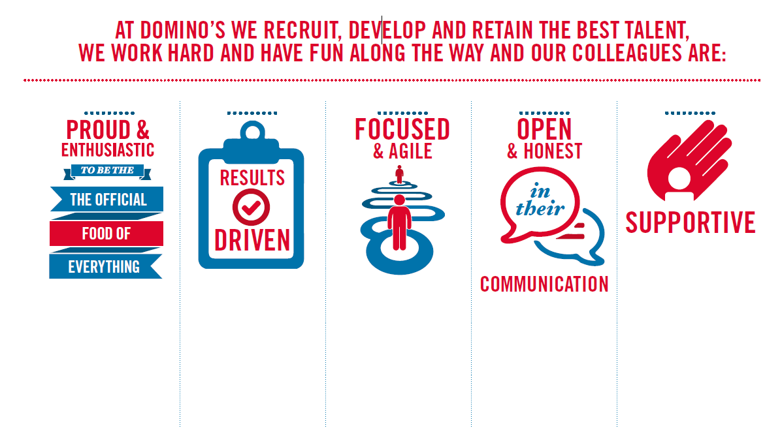
Proud & Enthusiastic: A positive advocate of their brand energises others through their passion.

Results Driven: Exceeds goals, pushes themselves to deliver, gets the job done at pace.

Focused & Agile: Works towards business goals, flexible to adapt and innovate as needed.

Open & Honest: Has sincere and two-way conversations, listens to and respects the views of others.

Supportive: Encourages and helps others, builds relationships, contributes to a positive environment

