Role Title: | Warehouse Team Leader
Location: | Cambuslang
Reports to Role: | Depot Shift Manager
Direct Reports: | Warehouse Ops
Grade: | G
Notice Period: | 4 weeks
Version Number and date: | May 2025

ROLE PURPOSE
Provide support to the Shift Manager in managing a team of operatives goods in and picking and loading, to meet the requirements of the customers’ orders within the allocated timeframe, whilst ensuring that the process is followed in line with policies and procedures.

MAIN AREAS OF RESPONSIBILITY
- Lead, motivate and supervise a team of Warehouse Operatives, ensuring a fully engaged team who work effectively to meet agreed KPI’s
- Participate in managing the day-to-day activities within Warehouse whilst sharing activities on the with Operatives as required.
- Manage the resources of Warehouse Operatives, including agency colleagues, on shift planning, holiday and overtime planning etc and absence management, including conducting Return to Work interviews.
- Ensuring all products are of the right quality within their use by date and escalate any concerns to the Manager/Technical team.
- Manage the safe start of shift by completing start up checks.
- Continuous monitoring of picking and loading standards ensuring checks are completed without exceptions and escalating any issues.
- Work closely with Production and Transport teams providing support where required ensuring the safe and accurate completion of all tasks
- Carry out weekly stock checks, ensuring data is reported D365 is updated accordingly
- Maintain the maintenance and cleanliness of the Warehouse throughout the shift.
- Comply with all legal and Company policies and procedures regarding health and safety to ensure you work in a manner that keeps you and your colleagues safe.
- Manage the day to day operations to ensure compliance with Health and Safety, FSSC standards, DPI standards and local food safety legislation.
The main areas of responsibility are not intended to be exhaustive but gives a general indication of the tasks involved. It is the nature of the Company that tasks, and responsibilities are in many circumstances, unpredictable and varied. All colleagues are therefore, expected to work in a flexible way when the occasion arises and acknowledge that tasks not specifically covered in their role profile are not excluded.
ACCOUNTABILITY
- Follow standard operating procedures at all time to health and safety and food safety guidelines.
- Lead the Warehouse team to meet completion of daily targets.
- Highlighting and supporting the resolution of any areas of concern within the products or the facility.

KNOWLEDGE, SKILLS, ABILITY & EXPERIENCE
- Understanding of the Health & Safety Legislation and Food Safety Standards.
- Working to a BRC accreditation, with experience and understanding of.
- Experience within a food production environment.
- COSHH Certificate and understanding of HACCP.
- Education to a minimum of GCSE/Standard Grade Level (including Math & English)
- Ability to work within a team to achieve daily production targets.
- Ability to communicate with all colleagues and maintain strong working relationships.

COMPETENCIES
At Domino’s we recruit, develop and retain the best talent, we work hard and have fun along the way, and our colleagues are;
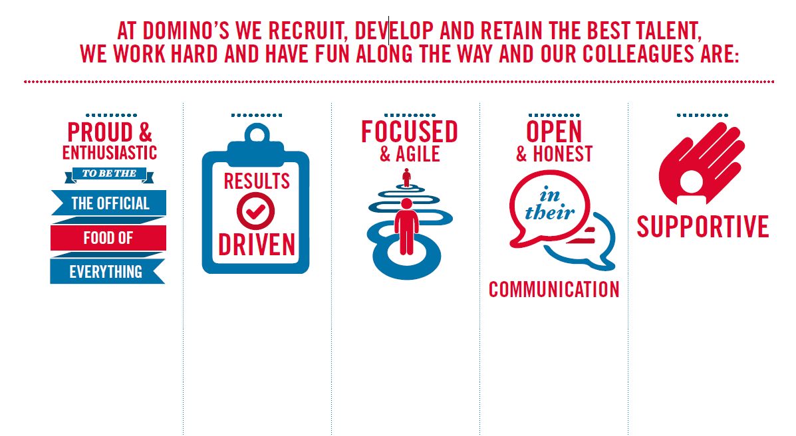
Proud & Enthusiastic: Expert understanding of functional area, acting as a coach to passionately inspire, motivate
and share knowledge with others to achieve success

Results Driven: Sets and maintains high performance standards with ability to problem solve,
motivating self and others to translate action plans in to results

Focused & Agile: Acts with customers in mind at all times, prioritising what will make a difference to
colleagues, customers and franchisees

Open & Honest: Excellent communications skills encouraging two way positive and developmental
feedback at all levels

Supportive: Strong interpersonal and influencing skills to build and maintain networks internally
and across the business to collaboratively achieve results

